Lab 4: Random Processes
ELECENG 3TR4: Communication Systems

Dr. Jun Chen

Kamya Dodiya – 400528145 – dodiyak
Amaiam Haque – 400520641 – haquea24

Experiment #1: Evaluation of Autocorrelation and Power Spectral Density

Part i):
For a linear time-invariant system driven by a WSS random process,
$$S_{y}\left(f\right)=S_{w}\left(f\right)⋅ {\left|H\left(f\right)\right|}^{2}$$
Thus:
$$S_{y}\left(f\right)=\left\{\begin{aligned}\frac{N_{0}}{2}, &|f|≤B \\ 0, &|f|>B\end{aligned}\right. \\ B=250Hz$$
The output PSD is rectangular over the passband $|f|≤250Hz$.

The autocorrelation is the inverse Fourier transform of the PSD:
$$R_{y}\left(τ\right)=\int_{-∞}^{∞}{Sy(f) e^{j2πfτ} df}$$
Substituting Sy(f):
$$R_{y}\left(τ\right)=\int_{-B}^{B}{\frac{N_{0}}{2} e^{j2πfτ} df} \\ R_{y}\left(τ\right)=\frac{N_{0}}{2} ×\frac{e^{j2πBτ}-e^{-j2πBτ}}{j2πτ} \\ R_{y}\left(τ\right)=\frac{N_{0}}{2} ×\frac{\sin\left(2πBτ\right)}{πBτ} \\ R_{y}\left(τ\right)=N_{0} ×\operatorname{sinc}\left(2Bτ\right)$$Below are the resulting plots from the MATLAB code:
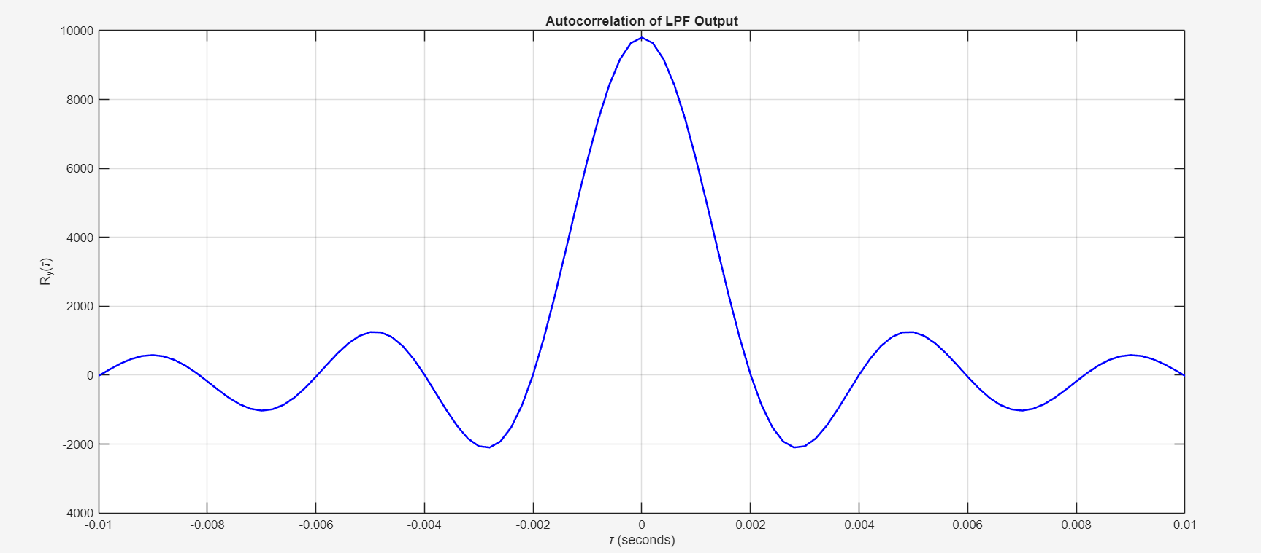
- The autocorrelation function is symmetric about $τ=0$, as expected for a real-valued stationary random process.
- The maximum value occurs at $τ=0$, representing the total average power of the output signal.
- Zero-crossings are observed at multiples of approximately 0.002 seconds.
- The shape follows a sinc function, decaying in amplitude as $∣τ∣$ increases.
- Side lobes decrease in magnitude, consistent with the $1/∣τ∣$ decay predicted by theory.

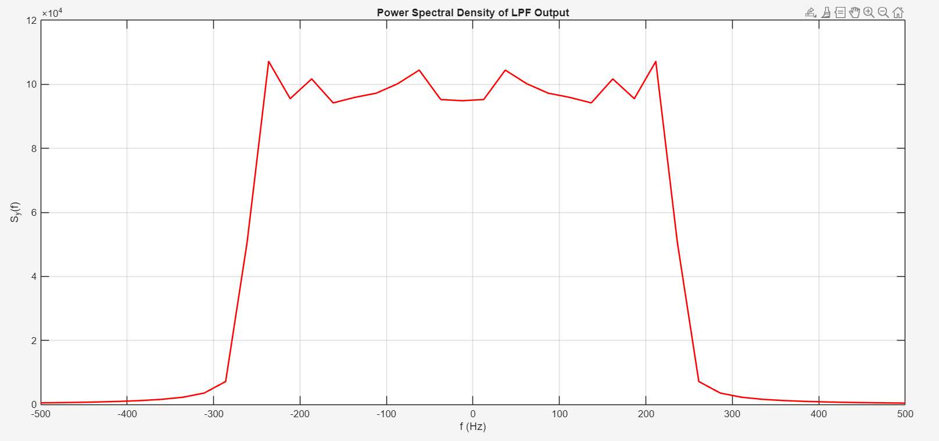

- The PSD is approximately constant (flat) for frequencies within the passband $∣f∣≤250$ Hz.
- A sharp roll-off occurs near $f=±250$ Hz, corresponding to the filter cutoff frequency.
- The PSD drops to near-zero values outside the passband, confirming the low-pass filtering action.
- Small ripples are present in the stopband and near the cutoff edges.
- These ripples are due to the finite length of the autocorrelation sequence used in the FFT (windowing effect).

Comparing theoretical and numerical results:
- The computed autocorrelation closely matches the theoretical sinc shape, especially near $τ=0$.
- The first zero-crossing occurs at approximately 0.002 seconds, which agrees with the theoretical value of $1/(2B)=1/500=0.002$ seconds.
- The numerical PSD is flat within $∣f∣≤250$ Hz, matching the theoretical rectangular spectrum.
- The sharp transition at the band edges is clearly visible, confirming the ideal LPF characteristic.
- Small discrepancies between theory and computation are observed due to several factors:
  - Finite data length (only 100,000 samples), which limits the accuracy of ergodic approximations.
  - Discrete-time sampling effects, as the theoretical analysis assumes continuous time.
  - Truncation of the autocorrelation at a finite number of lags (maxlag = 100), which introduces spectral leakage.
  - Gibbs phenomenon at the cutoff frequency, caused by the abrupt truncation of the autocorrelation sequence.
- Despite these minor discrepancies, the overall agreement is excellent and validates the Wiener-Khinchin theorem and linear system theory for WSS random processes.

Part ii):
Resulting MATLAB plots:
Maxlog = 100:
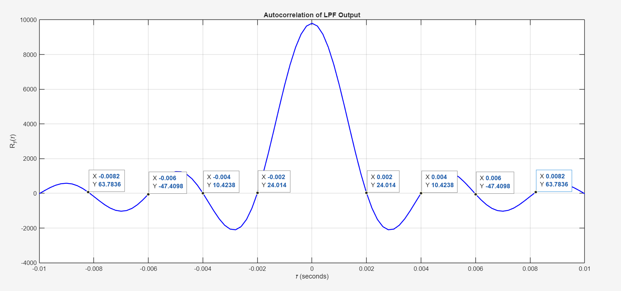


Maxlog = 200:
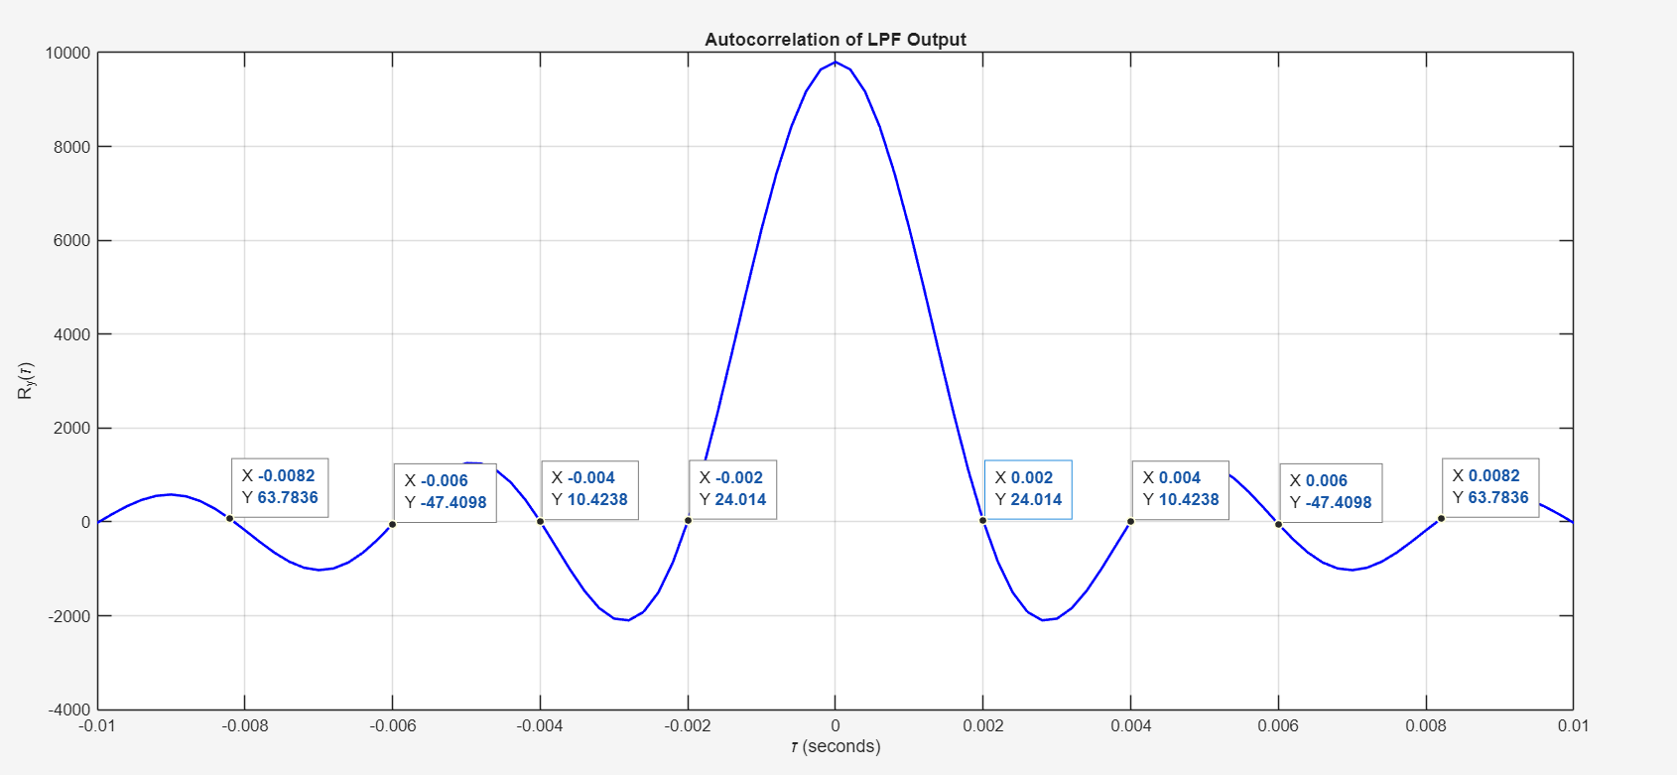
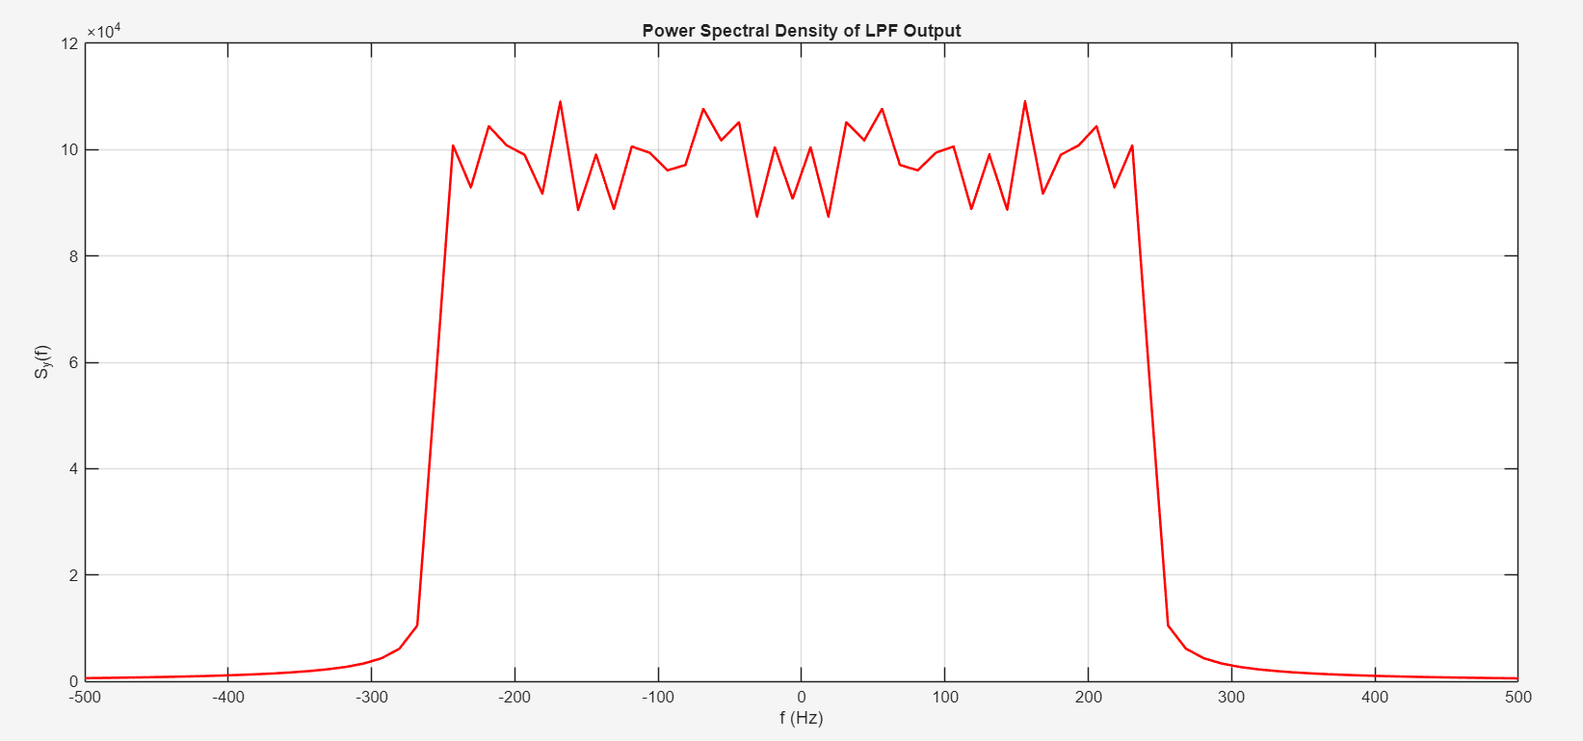

Maxlog = 500:
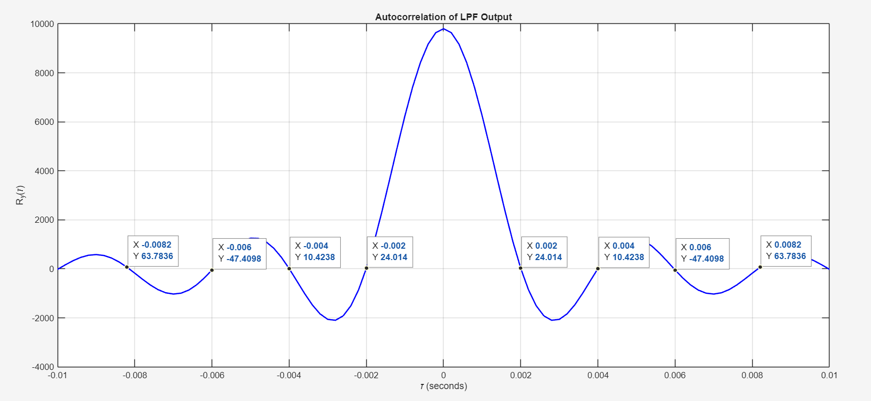
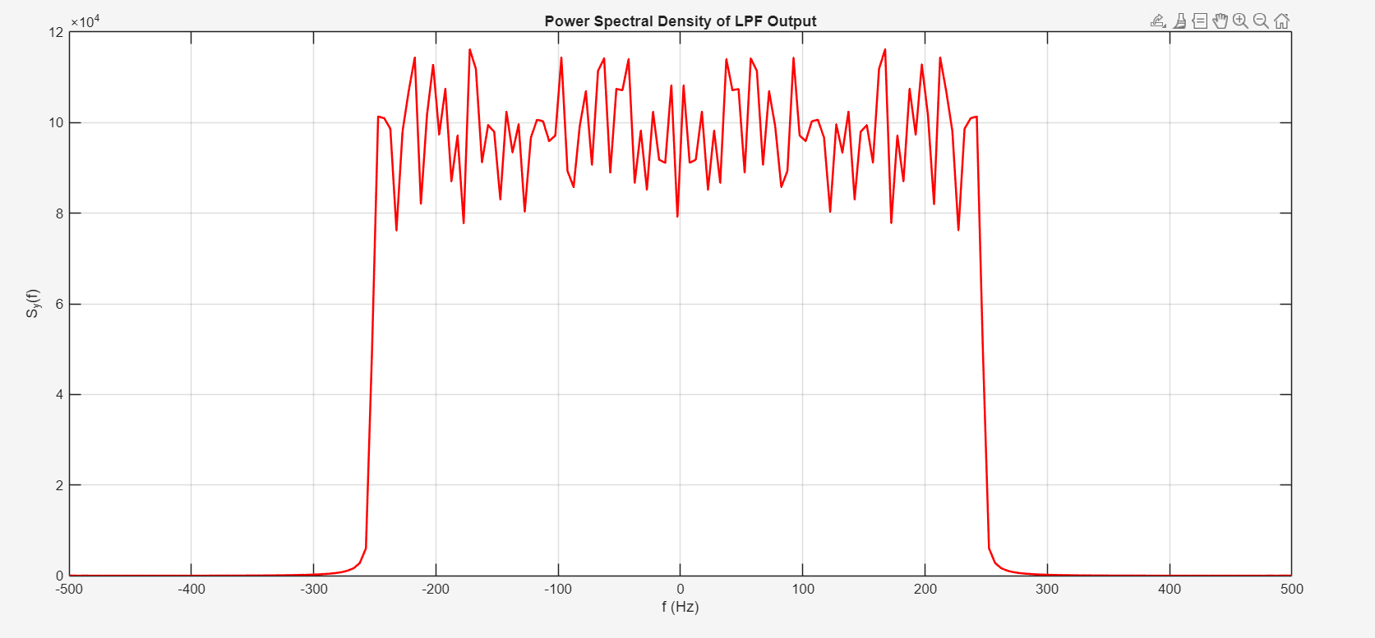

The numerically computed autocorrelation and power spectral density agree with theoretical predictions for an ideal low-pass filter driven by white noise. The autocorrelation exhibits a sinc shape with zero-crossings at multiples of $1/(2B)=0.002$ seconds, and the PSD is flat within the passband $∣f∣≤250$ Hz. Small discrepancies are attributed to finite sample size and discrete-time processing.

MATLAB Code:
%% ELEC 3TR4 - LAB 4 EXPERIMENT 1

clear
format long e
tend = 10;
tbegin = -10;
N=100000;
tstep = (tend-tbegin)/N;
sampling_rate = 1/tstep;
% Time window =
tt = tbegin:tstep:tend-tstep;
load('lab4_num_expt1')
% load('lab4_num_expt2')
% load('lab4_num_expt3')
maxlag = 100;
% Autocorrelation of yt
Ry = xcorr(yt,yt,maxlag);
% tau vector
tau_vec = -(maxlag*tstep):tstep:maxlag*tstep;
% Abs. PSD corresponding to yt
Sy = abs(fftshift(fft(fftshift(Ry))));
% define the frequency vector corresponding to tau_vec
Ntau = length(tau_vec);
% Nyquist sampling rate
fmax = sampling_rate/2;
fmin = -fmax;
fstep = (fmax-fmin)/Ntau;
% Frequency window
freq = fmin:fstep:fmax-fstep;

%% Plots
figure(1);
plot(tau_vec, Ry, 'b-', 'LineWidth', 1.5);
xlabel('\tau (seconds)'); ylabel('R_y(\tau)');
title('Autocorrelation of LPF Output');
grid on; xlim([-0.01, 0.01]);

figure(2);
plot(freq, Sy, 'r-', 'LineWidth', 1.5);
xlabel('f (Hz)'); ylabel('S_y(f)');
title('Power Spectral Density of LPF Output');
grid on; xlim([-500, 500]);

Experiment #2: A Sinusoid Buried in Noise

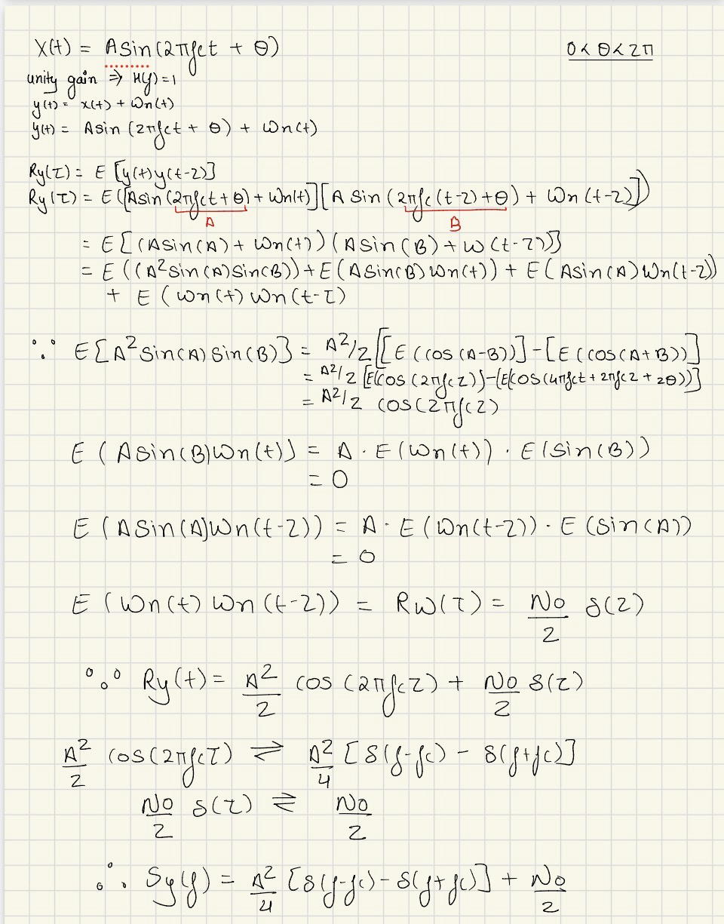
Theoretical derivation:

Part i):
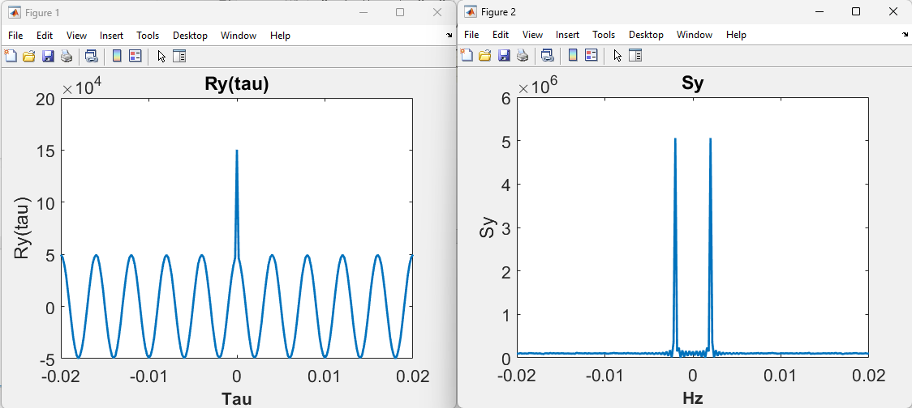
A peak at 0 was observed in autocorrelation plot this is due to effect of white noise which strongly reflects at point 0 rather than the whole signal.

Part ii):
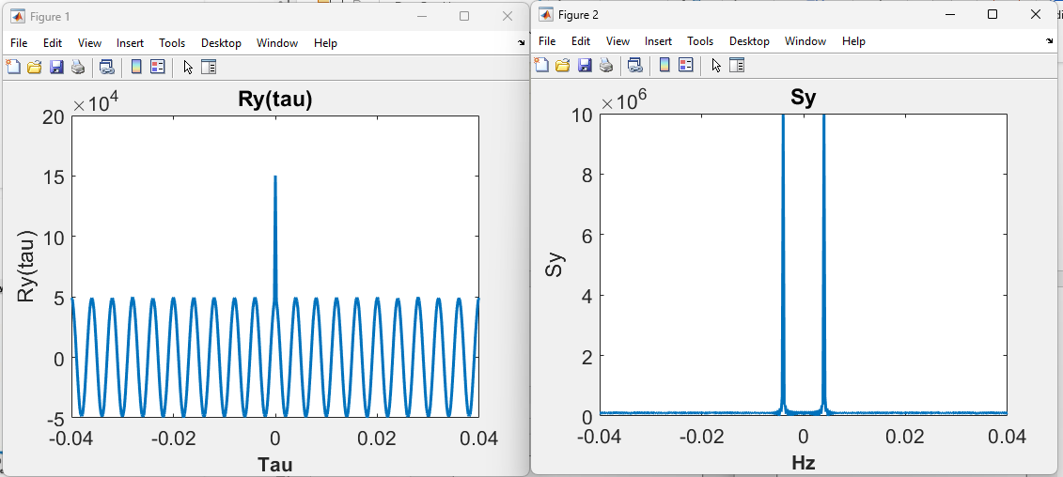
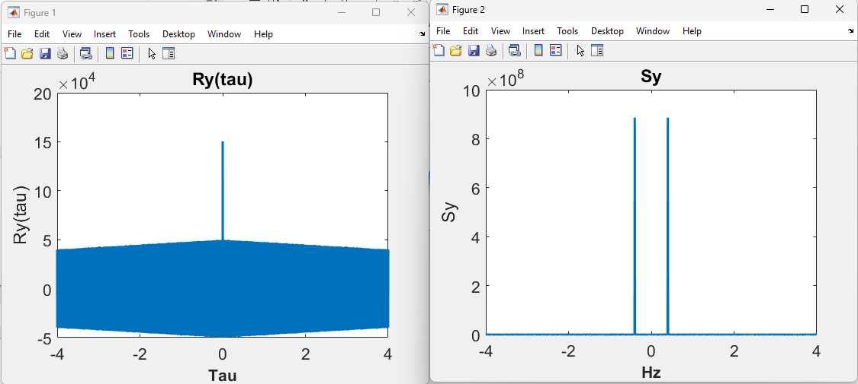
It was observed that as maxlag increases frequency resolution increases, at maxlag of 20000 the frequency converges to approximately 250Hz. With increasing frequency, the plot becomes sharper and precise with less noise around it. This observation matches theoretical derivation of Ry(tau) and Sy. Theoretically there should be 2 spikes in frequency domain at equal distance from 0 which can be seen in the MATLAB simulation.
Maxlag | Fc(Hz)
100 | 236.31
200 | 243.14
20000 | 249.93

Part iii):
Graph below shows Y(t) as a function of time. As the graph is dense and buried under noise it is hard to estimate frequency directly from the graph. Autocorrelation graphing serves as a great tool which allows us to analyze graph without noise and identify dominant frequency.

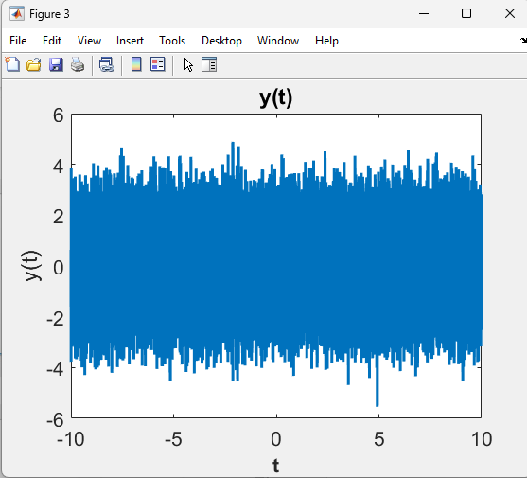
MATLAB Code:
%This code sets up the time and frequency vectors for all the numerical
%experiments of Lab3
clear
format long e
tend = 10;
tbeg = -10;
N=100000;
tstep = (tend-tbeg)/N;
sampling_rate = 1/tstep;

%Time window =
tt = tbeg:tstep:tend-tstep;

%load('lab4_num_expt1')
load('lab4_num_expt2')
%load('lab4_num_expt3')

maxlag = 100;
%Autocorrelation of yt
Rxy = xcorr(yt,yt,maxlag);
%tau vector
tau_vec = -(maxlag*tstep):tstep:maxlag*tstep;
%Abs. PSD corresponding to yt
Sy = abs(fftshift(fft(fftshift(Rxy))));
%define the frequency vector corresponding to tau_vec
Ntau = length(tau_vec);
%Nyquist sampling rate
fmax = sampling_rate/2;
fmin = -fmax;
fstep = (fmax-fmin)/Ntau;
%Frequency window
freq = fmin:fstep:fmax-fstep;
%Figure
figure(1)
Hp1 = plot(tau_vec, Rxy);
set(Hp1,'LineWidth',2)
Ha = gca;
set(Ha,'FontSize',16)
Hx = xlabel('Tau');
set(Hx,'FontWeight','bold','FontSize',16)
Hy = ylabel('Ry(tau)');
set(Hx,'FontWeight','bold','FontSize',16)
title('Ry(tau)');
%2
figure(2)
Hp1 = plot(tau_vec, Sy);
set(Hp1,'LineWidth',2)
Ha = gca;
set(Ha,'FontSize',16)
Hx = xlabel('Hz');
set(Hx,'FontWeight','bold','FontSize',16)
Hy = ylabel('Sy');
set(Hx,'FontWeight','bold','FontSize',16)
title('Sy');
%3
figure(3)
Hp1 = plot(tt, yt);
set(Hp1,'LineWidth',2)
Ha = gca;
set(Ha,'FontSize',16)
Hx = xlabel('t');
set(Hx,'FontWeight','bold','FontSize',16)
Hy = ylabel('y(t)');
set(Hx,'FontWeight','bold','FontSize',16)
title('y(t)');

Experiment #3: Delay Estimation
Signal model:
The transmitted signal is a Gaussian pulse centered at $t=T$:
$$x(t)=e^{-(t-T)^{2}},t∈R$$
The channel introduces a delay of $T$ seconds and adds white noise:
$$y(t)=x(t-T)+w(t)=e^{-(t-2T)^{2}}+w(t)$$
where:
- $T$ is the unknown delay to be estimated
- $w(t)$ is zero-mean white noise with variance $σ_{w}^{2}$

Why Direct Observation Fails:
When the noise power is large relative to the signal power (low signal-to-noise ratio, SNR), the Gaussian pulse is buried in noise:
$$\text{SNR}=\frac{max⁡∣x(t)∣^{2}}{σ_{w}^{2}}=\frac{1}{σ_{w}^{2}}$$
If $σ_{w}^{2}≫1$, then:
$$y(t)=\underset{\text{signal}}{\underset{⏟}{e^{-(t-2T)^{2}}}}+\underset{\text{noise}}{\underset{⏟}{w(t)}}≈w(t)$$
The pulse becomes visually undetectable in the time-domain plot.

Cross-Correlation Method:
The cross-correlation between $y(t)$ and $x(t)$ is defined as:
$$R_{yx}(τ)=E\left[y(t)x(t+τ)\right]$$
Substituting $y(t)=x(t-T)+w(t)$:
$$R_{yx}(τ)=E\left[x(t-T)x(t+τ)\right]+E\left[w(t)x(t+τ)\right]$$
Since $w(t)$ and $x(t)$ are uncorrelated and zero-mean:
$$E\left[w(t)x(t+τ)\right]=0$$
Therefore:
$$R_{yx}(τ)=E\left[x(t-T)x(t+τ)\right]$$
For a deterministic signal $x(t)$, the expectation becomes a time average. By the properties of correlation:
$$R_{yx}(τ)=R_{xx}(τ+T)$$
where $R_{xx}(τ)$ is the autocorrelation of $x(t)$.
Maximum of Cross-Correlation:
The autocorrelation $R_{xx}(τ)$ achieves its maximum at $τ=0$:
$$R_{xx}(0)≥R_{xx}(τ)∀τ$$
Thus:
$$R_{yx}(τ)=R_{xx}(τ+T)$$
is maximized when:
$$τ+T=0⇒τ=-T$$
Therefore:
$$\boxed{\hat{T}=-arg⁡\underset{τ}{max⁡}R_{yx}(τ)}$$
The delay $T$ is estimated by finding the lag at which the cross-correlation peaks.
Why Autocorrelation of $y(t)$ Fails:
The autocorrelation of $y(t)$ is:
$$R_{yy}(τ)=E\left[y(t)y(t+τ)\right]$$
Substituting $y(t)=x(t-T)+w(t)$:
$$\begin{matrix}R_{yy}(τ) & =E\left[x(t-T)x(t+τ-T)\right]+E\left[w(t)w(t+τ)\right] \\ & +E\left[x(t-T)w(t+τ)\right]+E\left[w(t)x(t+τ-T)\right]\end{matrix}$$
Since signal and noise are uncorrelated and zero-mean:
$$R_{yy}(τ)=R_{xx}(τ)+R_{ww}(τ)$$
where $R_{ww}(τ)=σ_{w}^{2}δ(τ)$ for white noise.
Key observation: $R_{yy}(τ)$ does not contain information about the delay $T$ because:
$$R_{yy}(τ)=R_{xx}(τ)+σ_{w}^{2}δ(τ)$$
The delay $T$ cancels out, thus the autocorrelation of $y(t)$ is shift-invariant and it only depends on the relative time difference, not the absolute delay.

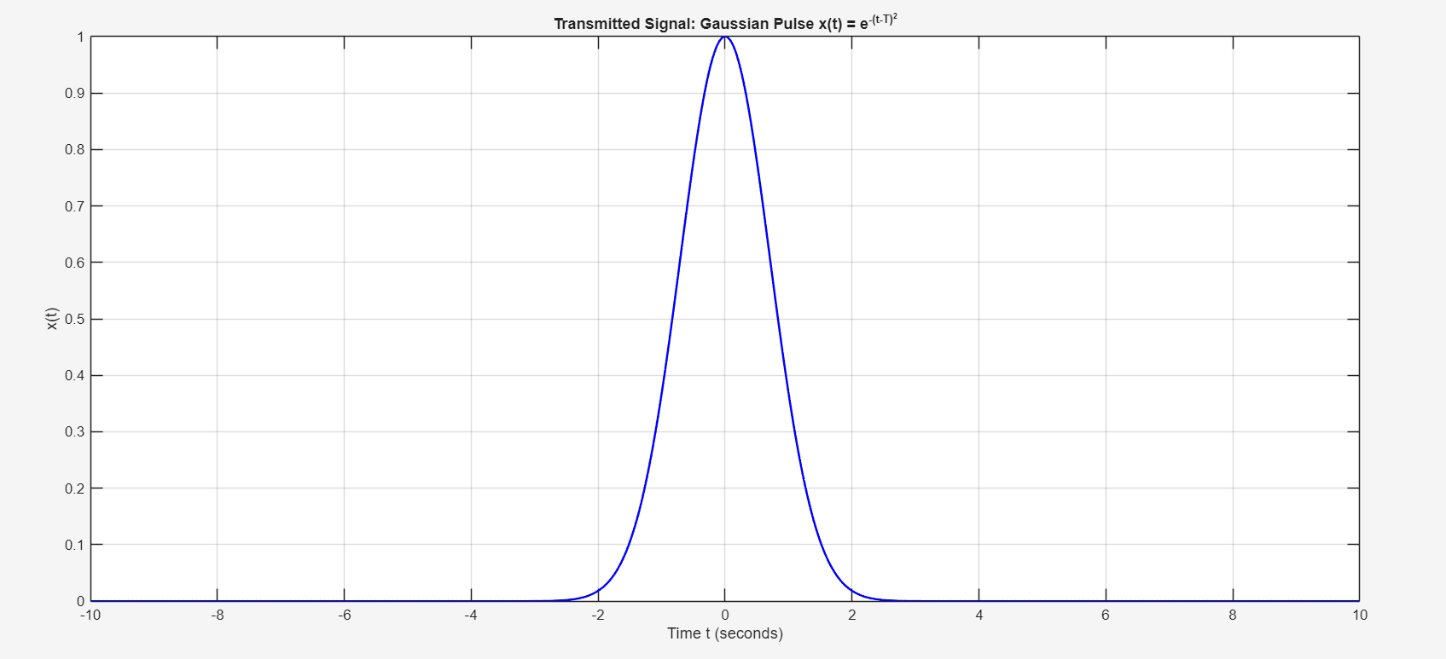
- Clean Gaussian pulse $x(t)=e^{-(t-T)^{2}}$
- Peak occurs at $t=T$

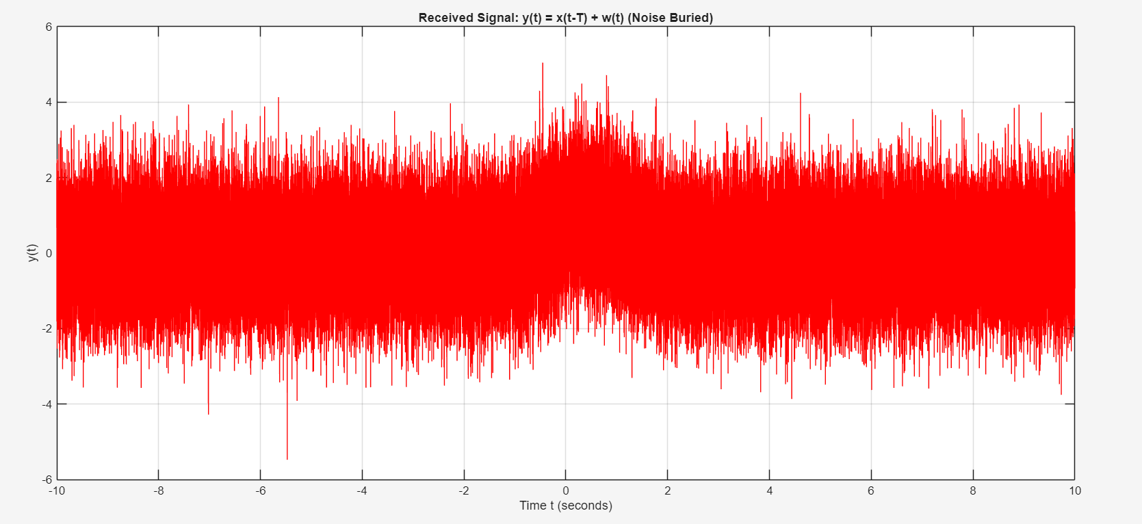
- The Gaussian pulse is completely obscured by additive white noise
- No clear peak is visible in the time-domain
- Direct estimation of $T$ by inspection fails because $w(t)≫x(t-T)$ in amplitude

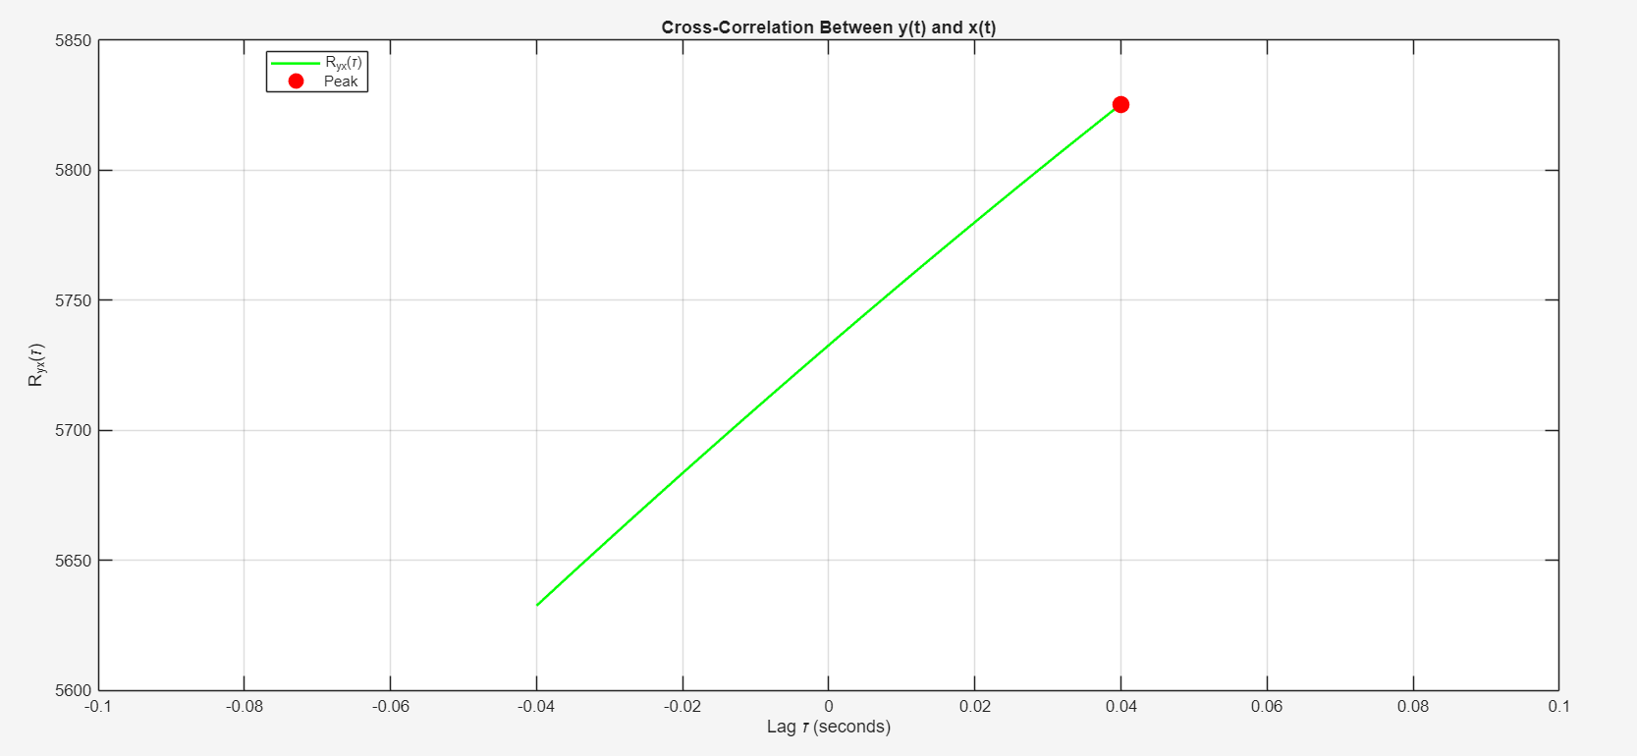
- A clear peak appears at $τ=-T$
- The peak is sharp and easily detectable despite the noise
- Why it works: Cross-correlation averages out the uncorrelated noise while reinforcing the correlated signal component
Mathematical explanation:
$$R_{yx}(τ)=\frac{1}{N}\sum_{n=1}^{N}{y(n)x(n+τ)}$$
For $τ=-T$:
$$R_{yx}(-T)=\frac{1}{N}\sum_{n=1}^{N}{\left[x(n-T)+w(n)\right]}x(n-T) \\ R_{yx}(-T)=\underset{\text{signal power}}{\underset{⏟}{\frac{1}{N}\sum_{n=1}^{N}{[x(n-T)}]^{2}}}+\underset{≈0\text{ (noise averages out)}}{\underset{⏟}{\frac{1}{N}\sum_{n=1}^{N}{w(n)x(n-T)}}}$$
The noise term tends to zero as $N→∞$ (by the law of large numbers), while the signal term is maximized.

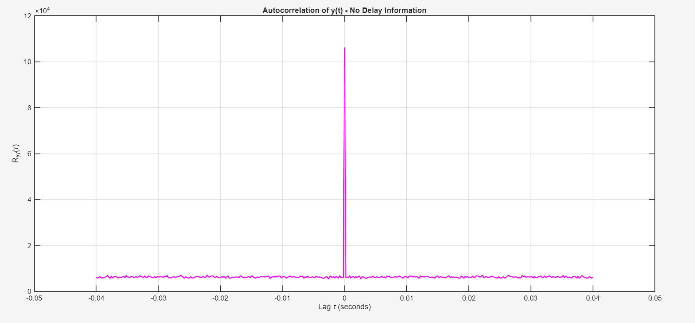
- Shows a peak at $τ=0$ (due to signal + noise power)
- Shows no peak at $τ=±T$
- Cannot estimate the delay because:
$$R_{yy}(τ)=R_{xx}(τ)+σ_{w}^{2}δ(τ)$$
The delay $T$ cancels out entirely, autocorrelation is shift-invariant.

MATLAB Code:
%% ELEC 3TR4 - LAB 4 EXPERIMENT 3
clear;
format long e;
tend = 10;
tbegin = -10;
N = 100000;
tstep = (tend - tbegin) / N;
sampling_rate = 1 / tstep;
% Time window =
tt = tbegin : tstep : tend - tstep;
% load('lab4_num_expt1')
% load('lab4_num_expt2')
load('lab4_num_expt3'); % Contains 'xt' and 'yt'
maxlag = 200; % Large enough to capture the delay
% cross-correlation between y(t) and x(t)
Ryx = xcorr(yt, xt, maxlag);
% tau vector
tau_vec = (-maxlag : maxlag) * tstep;
% find the lag at which cross-correlation is maximum
[max_val, max_idx] = max(Ryx);
estimated_tau = tau_vec(max_idx);
% estimated delay T = -tau_peak (since R_yx peaks at tau = -T)
estimated_T = -estimated_tau;
% autocorrelation of y(t) for comparison
Ryy = xcorr(yt, yt, maxlag);

%% Plots
% Figure 1: Transmitted signal x(t)
figure(1);
plot(tt, xt, 'b-', 'LineWidth', 1.5);
xlabel('Time t (seconds)');
ylabel('x(t)');
title('Transmitted Signal: Gaussian Pulse x(t) = e^{-(t-T)^2}');
grid on;
% Figure 2: Received signal y(t) (buried in noise)
figure(2);
plot(tt, yt, 'r-', 'LineWidth', 0.5);
xlabel('Time t (seconds)');
ylabel('y(t)');
title('Received Signal: y(t) = x(t-T) + w(t) (Noise Buried)');
grid on;
% Figure 3: Cross-correlation R_yx(tau)
figure(3);
plot(tau_vec, Ryx, 'g-', 'LineWidth', 1.5);
hold on;
plot(estimated_tau, max_val, 'ro', 'MarkerSize', 10, 'MarkerFaceColor', 'r');
xlabel('Lag \tau (seconds)');
ylabel('R_{yx}(\tau)');
title('Cross-Correlation Between y(t) and x(t)');
legend('R_{yx}(\tau)', 'Peak', 'Location', 'best');
grid on;
xlim([-0.1, 0.1]);
% Add text annotation
text(estimated_tau + 0.1, max_val*0.8, ...
sprintf('Peak at \\tau = %.4f s', estimated_tau), ...
'FontSize', 10, 'Color', 'red');
% Figure 4: Autocorrelation of y(t) for comparison
figure(4);
plot(tau_vec, Ryy, 'm-', 'LineWidth', 1.5);
xlabel('Lag \tau (seconds)');
ylabel('R_{yy}(\tau)');
title('Autocorrelation of y(t) - No Delay Information');
grid on;
xlim([-0.05, 0.05]);

%% Print Results
fprintf('Cross-correlation peak occurs at τ = %.6f seconds\n', estimated_tau);
fprintf('Estimated delay T = -τ_peak = %.6f seconds\n', estimated_T);

% Output in cmd window:
% Cross-correlation peak occurs at τ = 0.040000 seconds
% Estimated delay T = -τ_peak = -0.040000 seconds

